CHAP. 1 INTRODUCTION
PROBLEMS
1. What are the two main functions of an operating system?
>>> There are three main functions of an operating system. Two of them are as following;
Management of computers resources such as CPU, memory, printer and etc.
Execution of services provided by application software.
2. In Section 1.4, nine different types of operating systems are described. Give a list of applications for each of these systems (one per operating systems type).
>>> 9 different types of Operating Systems are:
Mainframe OS: For saving production databases of the busiest websites on the mainframe host.
Server OS: They help facilitate server roles like web servers, mail servers, and database server.
Multiprocessor OS
Personal Computer OS: Eg:- Windows 10
Handheld OS
Embedded OS
Sensor-Node OS
Real-Time OS: Online and Offline processing.
Smart Card OS
3. What is the difference between timesharing and multiprogramming systems?
>>> Main difference between multiprogramming and time sharing is that multiprogramming is the effective utilization of CPU time, by allowing several programs to use the CPU at the same time but time sharing is the sharing of a computing facility by several users that want to use the same facility at the same time. Each user on a time sharing system gets her own terminal and gets the feeling that she is using the CPU alone. Actually, time sharing systems use the concept of multiprogramming to share the CPU time between multiple users at the same time.
4. To use cache memory, main memory is divided into cache lines, typically 32 or 64 bytes long. An entire cache line is cached at once. What is the advantage of caching an entire line instead of a single byte or word at a time?
>>> Empirical evidence shows that memory access exhibits the principle of locality reference, where if one location is read then the probability of accessing nearby locations next is very high, particularly the following memory locations. So, by caching an entire cache line, the probability of a cache hit next is increased Also, modern hardware can do a block transfer of 32 or 64 bytes into a cache line much faster than reading the same data as individual words.

5. On early computers, every byte of data read or written was handled by the CPU (i.e., there was no DMA). What implications does this have for multiprogramming?
>>> It makes multiprogramming less favourable since it is no longer the case that when one process does I/O the CPU is completely free to work on other processes.

6. Instructions related to accessing I/O devices are typically privileged instructions, that is, they can be executed in kernel mode but not in user mode. Give a reason why these instructions are privileged.
>>> Access to I/O devices (e.g., a printer) is typically restricted for different users. Some users may be allowed to print as many pages as they like, some users may not be allowed to print at all, while some users may be limited to printing only a certain number of pages. These restrictions are set by system adminis- trators based on some policies. Such policies need to be enforced so that user- level programs cannot interfere with them.

7. The family-of-computers idea was introduced in the 1960s with the IBM System/360 mainframes. Is this idea now dead as a doornail or does it live on?
>>> It lives on today, with every major OS having a family of computers. A family of computers means a group of computers that differ in cost and performance but are able to run the same software on the same OS.
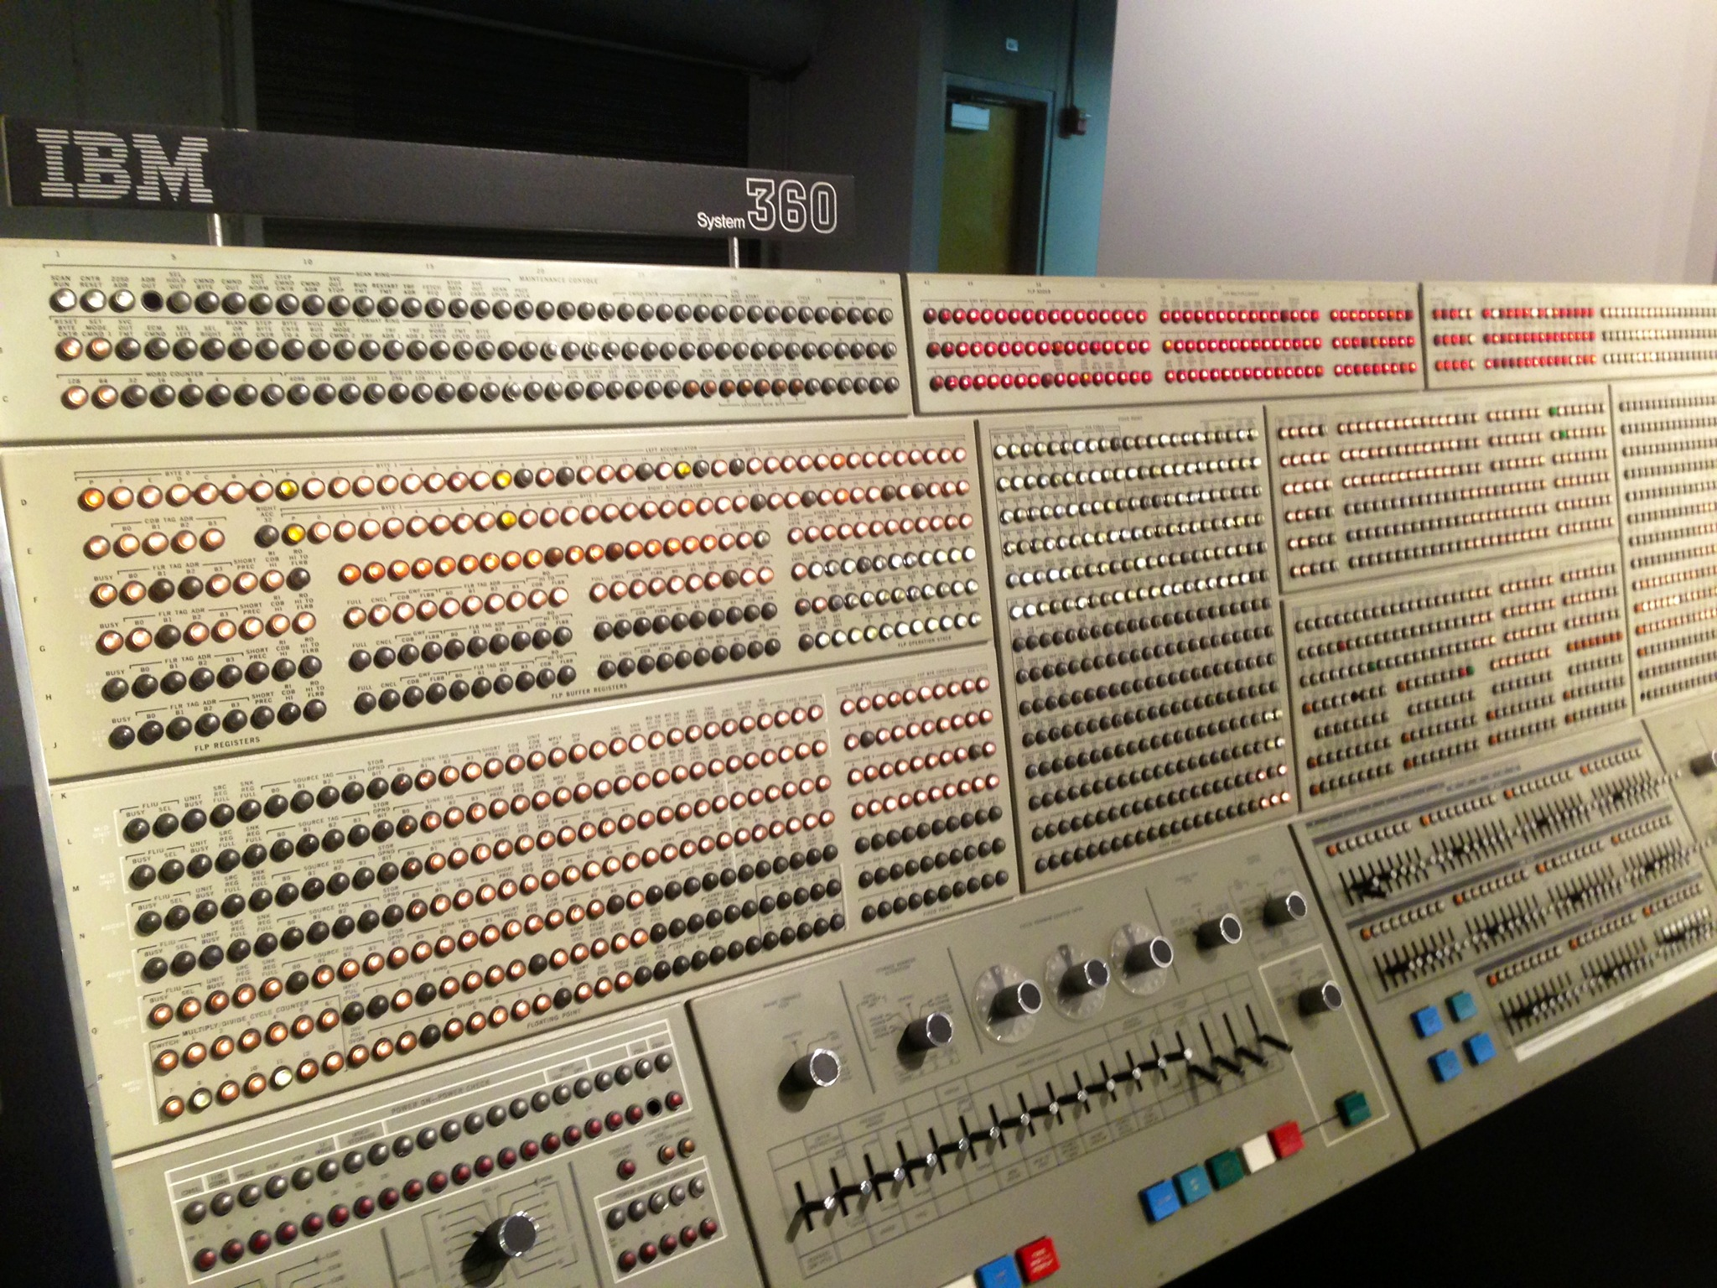

8. One reason GUIs were initially slow to be adopted was the cost of the hardware needed to support them. How much video RAM is needed to support a 25-line × 80-row character monochrome text screen? How much for a 1200 × 900-pixel 24-bit color bitmap? What was the cost of this RAM at 1980 prices ($5/KB)? How much is it now?
>>> A 25 x 80 character monochrome text screen requires a 2000-byte buffer. The 1200 900 pixel 24-bit color bitmap requires 3,240,000 bytes. In 1980 these two options would have cost $10 and $15,820, respectively. For current prices, check on how much RAM currently costs, probably pennies per MB.

9. There are several design goals in building an operating system, for example, resource utilization, timeliness, robustness, and so on. Give an example of two design goals that may contradict one another.
>>> Resource utilization and timeliness may contradict one another. When a resource is multiplexed, different programs or users take turns using a resource. Or they share the resource and each get part of it. Determining how the resource is multiplexed is the task of operating system. If resource is multiplexed, timeliness would change according to how a resource is shared.

10. What is the difference between kernel and user mode? Explain how having two distinct modes aids in designing an operating system.
>>>
USER MODE | KERNEL MODE
User Mode is a restricted mode, which the application programs are executing and starts out. | Kernel Mode is the privileged mode, which the computer enters when accessing hardware resources.
User Mode is considered as the slave mode or the restricted mode. | Kernel mode is the system mode, master mode or the privileged mode.
In User mode, a process gets their own address space. | In Kernel Mode, processes get single address space.
In User Mode, if an interrupt occurs, only one process fails. | In Kernel Mode, if an interrupt occurs, the whole operating system might fail.
In user mode, there are restrictions to access kernel programs. Cannot access them directly. | In kernel mode, both user programs and kernel programs can be accessed.

11. A 255-GB disk has 65,536 cylinders with 255 sectors per track and 512 bytes per sector. How many platters and heads does this disk have? Assuming an average cylinder seek time of 11 ms, average rotational delay of 7 msec and reading rate of 100 MB/sec, calculate the average time it will take to read 400 KB from one sector.
>>> Number of heads = 255 GB / (65536255512) = 16
Number of platters = 16/2 = 8
The time for a read operation to complete is seek time + rotational latency +
transfer time. The seek time is 11 ms, the rotational latency is 7 ms and the
transfer time is 4 ms, so the average transfer takes 22 msec.

12. Which of the following instructions should be allowed only in kernel mode?
(a) Disable all interrupts.
(b) Read the time-of-day clock.
(c) Set the time-of-day clock.(d) Change the memory map.
>>> Answer: (a)

13. Consider a system that has two CPUs, each CPU having two threads (hyperthreading). Suppose three programs, P0, P1, and P2, are started with run times of 5, 10 and 20 msec, respectively. How long will it take to complete the execution of these programs? Assume that all three programs are 100% CPU bound, do not block during execution, and do not change CPUs once assigned.
>>> Either 20, 25 or 30 msec depending on how they scheduled.
When splitting it up, the total time to finish it all is the time it takes for the core with the longest time to finish. Worst case is one core gets 5 msec and the other gets the 20 and the 10 (30 m sec).
14. A computer has a pipeline with four stages. Each stage takes the same time to do its work, namely, 1 nsec. How many instructions per second can this machine execute?
>>> Every nanosecond one instruction emerges from the pipeline. This means the machine is executing 1 billion instructions per second. It does not matter at all how many stages the pipeline has. A 10-stage pipeline with 1 nsec per stage would also execute 1 billion instructions per second. All that matters is how often a finished instruction pops out the end of the pipeline.

15. Consider a computer system that has cache memory, main memory (RAM) and disk, and an operating system that uses virtual memory. It takes 1 nsec to access a word from the cache, 10 nsec to access a word from the RAM, and 10 ms to access a word from the disk. If the cache hit rate is 95% and main memory hit rate (after a cache miss) is 99%, what is the average time to access a word?
>>> Average access time = 0.95 x 1 nsec (word is in the cache) + 0.05 x 0.99 x 10 nsec (word is in RAM, but not in the cache) + 0.05 x0.01 x10,000,000 nsec (word on disk only) = 5001.445 nsec = 5.001445 sec

16. When a user program makes a system call to read or write a disk file, it provides an indication of which file it wants, a pointer to the data buffer, and the count. Control is then transferred to the operating system, which calls the appropriate driver. Suppose that the driver starts the disk and terminates until an interrupt occurs. In the case of reading from the disk, obviously the caller will have to be blocked (because there are no data for it). What about the case of writing to the disk? Need the caller be blocked aw aiting completion of the disk transfer?
>>> Maybe. If the caller gets control back and immediately overwrites the data,
when the write finally occurs, the wrong data will be written. However, if the
driver first copies the data to a private buffer before returning, then the caller
can be allowed to continue immediately. Another possibility is to allow the
caller to continue and give it a signal when the buffer may be reused, but this
is tricky and error prone.

17. What is a trap instruction? Explain its use in operating systems.
>>> A trap instruction is a procedure call that synchronously transfers the control. It is a software interrupt generated by the user program or by an error when the operating system is needed by it to perform the system calls or an operation.
Thus, a trap instruction used to switch from the user mode of the system to the kernel mode.

18. Why is the process table needed in a timesharing system? Is it also needed in personal computer systems running UNIX or Windows with a single user?
>>> The process table is needed to store the state of a process that is currently suspended, either ready or blocked. Modern personal computer systems have dozens of processes running even when the user is doing nothing and no pro- grams are open. They are checking for updates, loading email, and many other things, On a UNIX system, use the ps -a command to see them. On a Windows system, use the task manager

19. Is there any reason why you might want to mount a file system on a nonempty directory? If so, what is it?
>>> One reason to mount a file system on a nonempty directory is when the whole content of the directory will be rendered useless with the content of the file system to be mounted. For example, a DVD contains four ISO9660 image files of four different titles of games has been mounted under /mnt/dvdrom. To play a game, the ISO9660 image of the game must be mounted first so that its content can be read. Because only one game can be played in a PC, there is no need to mount the image in another mount point. Instead, the image is also mounted under /mnt/dvdrom, hiding the file system of the DVD whose content is not needed to be directly accessible in user space. This design will also allow the use of a friendly menu by which the user can select which game to run. Since the user who executed the menu can mount the DVD under /mnt/dvdrom, the menu can also mount the selected image file under /mnt/dvdrom. This will eliminate the need of asking the user to which mount point the user has permission to mount the selected image file.
20. For each of the following system calls, give a condition that causes it to fail: fork, exec, and unlink.
>>> Fork can fail if there are no free slots left in the process table (and possibly if there is no memory or swap space left). Exec can fail if the file name given does not exist or is not a valid executable file. Unlink can fail if the file to be unlinked does not exist or the calling process does not have the authority to unlink it.
21. What type of multiplexing (time, space, or both) can be used for sharing the following resources: CPU, memory, disk, network card, printer, keyboard, and display?
>>> Time -- When a resource is time multiplexed, different programs or users take turns using it."
Space-- "each one gets part of the resource."

22. Can the
count = write(fd, buffer, nbytes);
call return any value in count other than nbytes? If so, why?
>>> If the call fails, for example because fd is incorrect, it can return −1. It can also fail because the disk is full, and it is not possible to write the number of bytes requested. On a correct termination, it always returns nbytes.

23. A file whose file descriptor is fd contains the following sequence of bytes: 3, 1, 4, 1, 5, 9, 2, 6, 5, 3, 5. The following system calls are made:
lseek(fd, 3, SEEK SET); read(fd, &buffer, 4);
where the lseek call makes a seek to byte 3 of the file. What does buffer contain after the read has completed?
>>> It contains the bytes: 1, 5, 9, 2.

24. Suppose that a 10-MB file is stored on a disk on the same track (track 50) in consecutive sectors. The disk arm is currently situated over track number 100. How long will it take to retrieve this file from the disk? Assume that it takes about 1 ms to move the arm from one cylinder to the next and about 5 ms for the sector where the beginning of the file is stored to rotate under the head. Also, assume that reading
occurs at a rate of 200 MB/s
.>>> Time to retrieve the file = 1 50 ms (Time to move the arm over track 50) + 5 ms (Time for the first sector to rotate under the head) + 10/200 1000 ms (Read 10 MB) = 105 ms

25. What is the essential difference between a block special file and a character special file?
>>> the essential difference between a block special file and a character special file are:

A block special file | A character special file
Allow the reading and writing of larger buffers of data at once. | Feed one character (byte) at a time.
Block devices are buffered | Character devices are unbuffered
Storage and memory devices are usually accessed as block devices | Serial ports and terminals usually accessed as a character device.

26. In the example given in Fig. 1-17, the library procedure is called read and the system call itself is called read. Is it essential that both of these have the same name? If not, which one is more important?
>>> It is more important for the library procedure to have that name. When the library procedure read traps to the kernel, it puts the code of the system call in a register. This code is used to index into a table. In other words, this code is critical to identify the system call being invoked, not the naming of the system call. On the other hand, the name of the library procedure is very important, since that is what appears in the program.

27. Modern operating systems decouple a process address space from the machine’s physical memory. List two advantages of this design.
>>> Two advantages of this design are:
_ This allows an executable program to be loaded in different parts of the ma- chine'smemory in different runs.
_ it enables program size to exceed the size of the machine's memory.

28. To a programmer, a system call looks like any other call to a library procedure. Is it important that a programmer know which library procedures result in system calls? Under what circumstances and why?
>>> As far as program logic is concerned it does not matter whether a call to a library procedure results in a system call.
But if performance is an issue, if a task can be accomplished without a system call the program will run faster.
Every system call involves overhead time in switching from the user context to the kernel context.
Furthermore, on a multiuser system the operating system may schedule another process to run when a system call completes, further slowing the progress in real time of a calling process.

29. Figure 1-23 shows that a number of UNIX system calls have no Win32 API equivalents. For each of the calls listed as having no Win32 equivalent, what are the consequences for a programmer of converting a UNIX program to run under Windows?
>>> Execuve - The programmer will be forced to create a new process using CreateProcess every time he or she wants to fork or execve. In other words, instead of being able to call just fork or execve alone, they we will have to call CreateProcess, which calls both of these UNIX commands.

Link - The programmer will not be able to duplicate files and have two files in different places refer to the same exact file.

Mount/Umount - The programmer could not dynamically add or subtract file systems or I/O systems and thus adjust the root and/or working directories.

Chmod - The programmer will not be able to set file permissions.

Kill - The programmer will not be able to send signals to specific processes.

30. A portable operating system is one that can be ported from one system architecture to another without any modification. Explain why it is infeasible to build an operating system that is completely portable. Describe two high-level layers that you will have in designing an operating system that is highly portable.
>>> One reason why it is infeasible because there is no way to specify path names. UNIX does not allow path names to be prefixed because it creates device dependence, therefore not portable.
Two high-level layers we should use to desig an operating system to get highlt portable:
- Layer 3: Input/Output Management - managing I/O devices and buffering the information streams to and from.
- Layer 2: Operator-processor communication - handled communication between each process and the operator console.

31. Explain how separation of policy and mechanism aids in building microkernel-based operating systems.
>>> By separating the policy for a function in the user-mode process, and keeping only the mechanism in the kernel, the core functionality is all that is left in the kernel. In this way, the microkernel concept is followed, moving the bulk of the code outside the kernel itself.
32. Virtual machines have become very popular for a variety of reasons. Nevertheless, they hav e some downsides. Name one.
>>> Virtual machines do not physically exist. It is a physical machine implemented virtually with the help of a software. One of the disadvantages is that it is not that efficient as a real one when accessing the hardware and the performance is poor.
33. Here are some questions for practicing unit conversions:
(a) How long is a nanoyear in seconds?
(b) Micrometers are often called microns. How long is a megamicron?
(c) How many bytes are there in a 1-PB memory?
(d) The mass of the earth is 6000 yottagrams. What is that in kilograms?
>>> The conversions are straightforward:
(a) A nanoyear is 10^9 x365 x24 x3600 = 31. 536 msec.
(b) 1 meter
(c) There are 250 bytes, which is 1,099,511,627,776 bytes.
(d) It is 6x10^24 kg or 6 x10^27 g.
34. Write a shell that is similar to Fig. 1-19 but contains enough code that it actually works so you can test it. You might also add some features such as redirection of input and output, pipes, and background jobs.
>>> Shell program
Implement the code:
The following shell program with the added features and similar to the given code segment is as given below:
//Header file section
#include
#include
#include
#include
#include
#include
#define MAXIMUM_ARGUMENTS10
#define MAXIMUM_LENGTH 100
Define the function prototype
//Function pototype
void child(int argument, char *argumentV[MAXIMUM_ARGUMENTS]);
//Main function
int main()
{
//Declare the varaibles declaration
int argument, n = 0, status;
char input_line[MAXIMUM_LENGTH],
*argumentV[MAXIMUM_ARGUMENTS], *cp;
const char *delimiter = " \t\n";
The loop is executed till true is set. The input is taken from the user and stop when key combination Ctrl+d is pressed by the user.

//Repeat the loop until the condition is true
while (1)
{
Prompting the user to enter an input values from the keyboard
//Read the input line
printf("sh-> ");
//condition to read the line
if (fgets(input_line, sizeof(input_line),
stdin) == NULL)
{
printf("Thanks!\n");
// exit from read mode
exit(0);
}//End if
//Assing thr input value to cp
cp = input_line;
// loop to split the tabs and blank spaces
for(argument = 0; argument <
MAXIMUM_ARGUMENTS; argument++)
{
// condition to break
if ((argumentV[argument] = strtok(cp,
delimiter)) == NULL)
break;
// set the pointer to NULL
cp = NULL;
}//End for loop
Condition to stop shell when specific word is entered by the user
//Check the condition
if(strcmp(argumentV[0], "Stop") == 0)
{
// display output
printf("Thanks!\n");
// exit from the shell
exit(0);
}//End if
//set the fork to the process id
pid_t process_id = fork();
// condition to check failure of fork
if(process_id == -1)
{
// display error message
perror("fork is failed ");
// exit from the shell
exit(1);
}//End if
else if(process_id == 0)
{
//execute the child process
child(argument, argumentV);
}//End else if
else
{
//Call the wait system call
wait(&status);
}//End else
}//End while
}//End main
Define the function for child process
//Function defintion
void child(int argument, char *argumentV[MAXIMUM_ARGUMENTS])
{
execvp(argumentV[0], argumentV);
}//End function

35. If you have a personal UNIX-like system (Linux, MINIX 3, FreeBSD, etc.) available that you can safely crash and reboot, write a shell script that attempts to create an unlimited number of child processes and observe what happens. Before running the experiment, type sync to the shell to flush the file system buffers to disk to avoid ruining the file system. You can also do the experiment safely in a virtual machine. Note: Do not try this on a shared system without first getting permission from the system administrator. The consequences will be instantly obvious so you are likely to be caught and sanctions may follow.
>>> Is good for multiprocessor architecture
Is good for multiprocessor architecture and if one thread is blocked does not cause the other thread to be blocked
If one thread is blocked does not cause the other thread to be blocked Is good for multiprocessor architecture and if one thread is blocked does not cause the other thread to be blocked

36. Examine and try to interpret the contents of a UNIX-like or Windows directory with a tool like the UNIX od program. (Hint: How you do this will depend upon what the OS allows. One trick that may work is to create a directory on a USB stick with one operating system and then read the raw device data using a different operating system that allows such access.)
>>> UNIX Another advantage of Unix systems is that getting rid of viruses is easier, as viruses can only infect user accounts and the root remains intact and pure.
Windows is less secure in the sense that it is simple to execute files with minimal permission. These can further lead to the installation of Malwares unknowingly on the system.
more secure by design. The primary protection on a Unix system is that executing a “.exe” file is much more difficult. Here executables cannot be processed without explicit permission as all processes in Unix are treated equally. But these are slowly changing as Unix distributions are moving more towards GUI and now relying on the application security itself.
Another advantage of Unix systems is that getting rid of viruses is easier, as viruses can only infect user accounts and the root remains intact and pure.
Windows is less secure in the sense that it is simple to execute files with minimal permission. These can further lead to the installation of Malwares unknowingly on the system.
UNIX is more secure by design. The primary protection on a Unix system is that executing a “.exe” file is much more difficult. Here executables cannot be processed without explicit permission as all processes in Unix are treated equally. But these are slowly changing as Unix distributions are moving more towards GUI and now relying on the application security itself.
---The end---

